**CURRENCY CONVERTOR**

**PROJECT GROUP MEMBER**

|  |  |
| --- | --- |
| **Students Id** | **Students Name** |
| ***Student1426616*** | ***Syed Muhammad Zain Sarfraz*** |
| ***Student1450998*** | ***Huda Shahid*** |
| ***Student1424649*** | ***Tayyaba Muslim*** |
| ***Student1452427*** | ***Jaisha Jaseem*** |
| ***Student1421636*** | ***Muhammad Anas*** |
| ***Student1407243*** | ***Muhammad Yasir*** |

**FACULTY**

**SIR HARIS NASEER**

**CO-ORDINATOR**

**MISS SANA**

**CURRICULUM**

**7062**

**BATCH**

**2302C2**

**Currency Convertor**

HOME

Help Center

Blog

Testimonials

Contact Us

Settings

Rate Alerts

Currency News

Currency News

Live Rate Alerts

Currency Exchange

**Home Page**

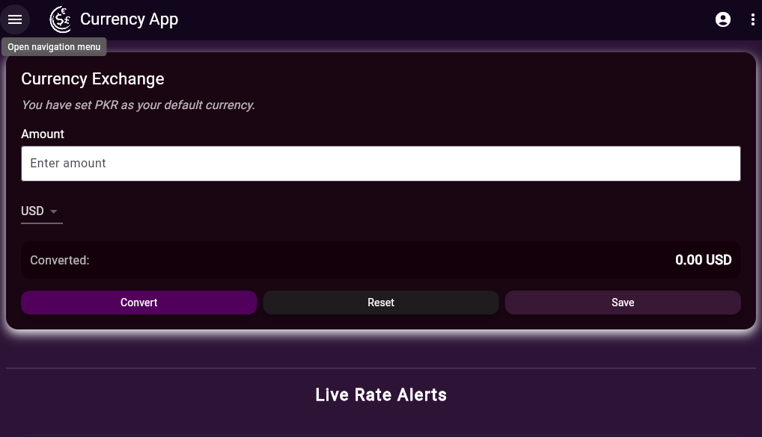

**Navbar**

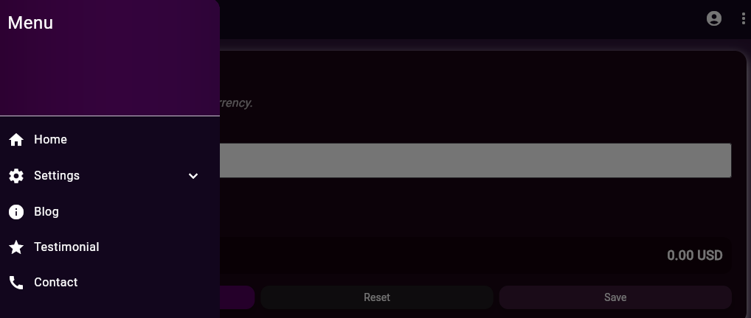

**Settings**

**Rate Alerts**

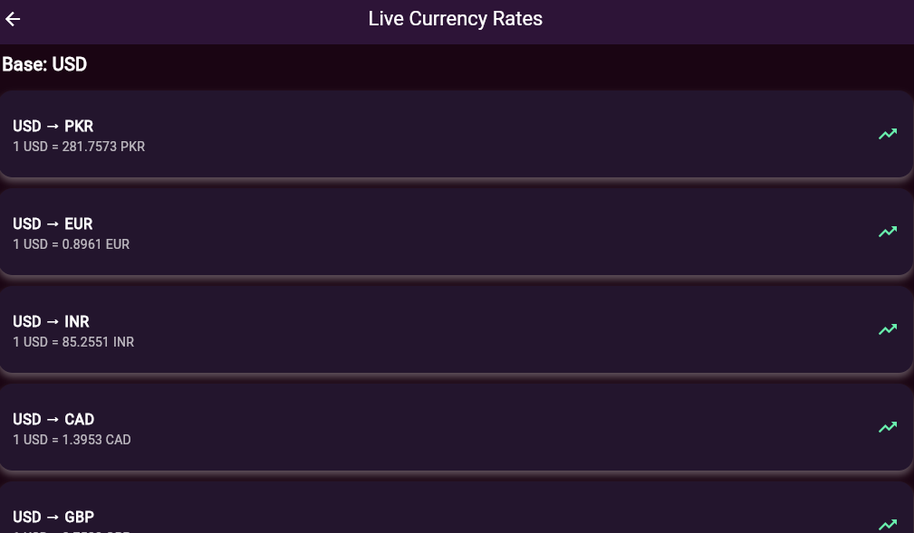

**Currency News**

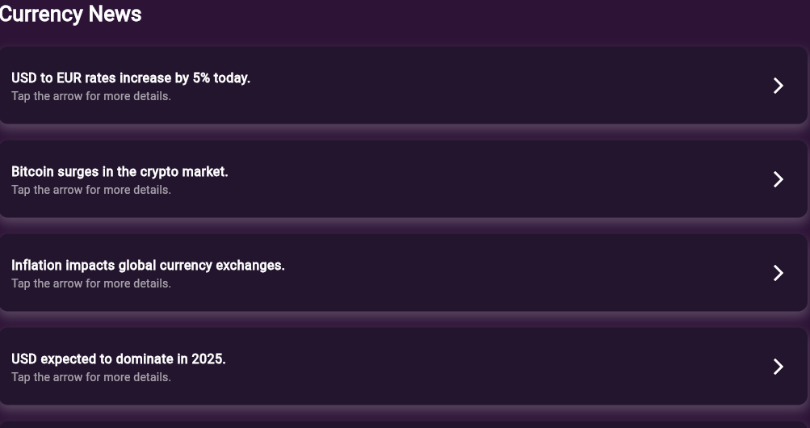

**Help Center**

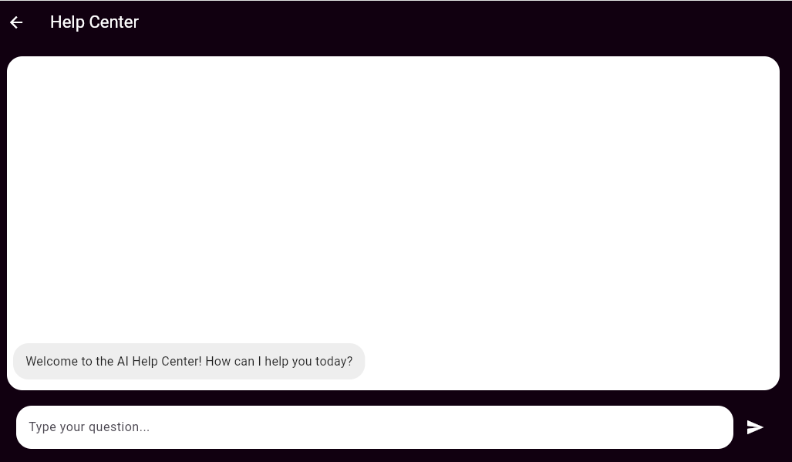

**Blog**



**Testimonial**

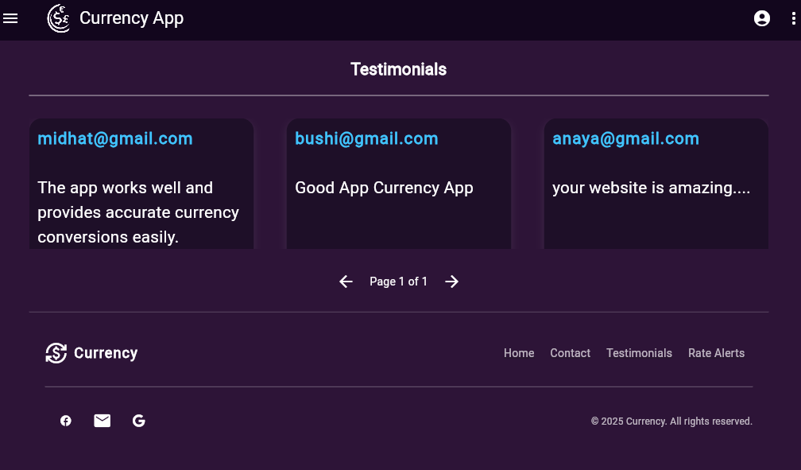

**Contact Us**

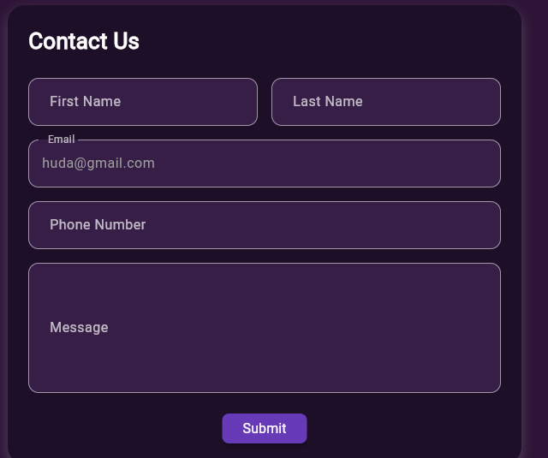

**Login**

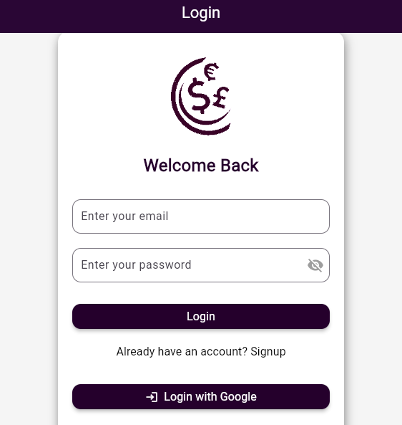

**Signup**

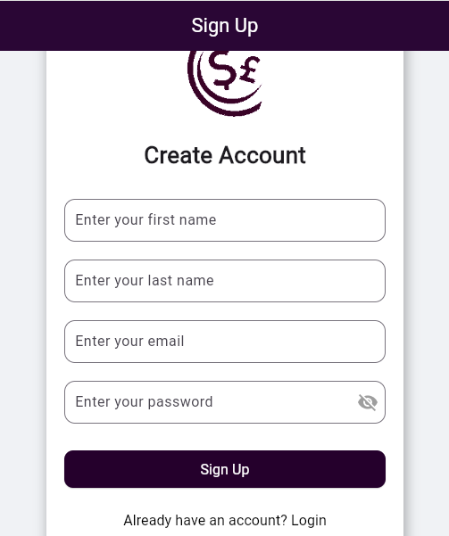

**Footer**



**Summary:**

At **CurrenSee**, we aim to simplify global currency exchange for everyday users, travellers, and businesses. Commissioned by **ABC Finance Ltd.**, this innovative app offers a real-time, secure, and user-friendly platform for seamless currency conversions. Key features include:

✔️ **Secure User Authentication**: Sign in using email, Google, or Facebook – all managed through Firebase for secure access.  
✔️ **Live Currency Conversion**: Instantly convert between global currencies using real-time exchange rates.  
✔️ **Conversion History**: Automatically logs past conversions with detailed information on rates, dates, and amounts.  
✔️ **Currency List & Details**: Explore searchable lists of supported currencies along with symbols and market info.  
✔️ **Rate Alerts**: Set preferred exchange rate thresholds and receive instant push notifications.  
✔️ **News & Market Trends**: Stay updated with curated blogs, financial news, and analytical market trends.  
✔️ **User Preferences**: Save default base currencies and recent choices for faster access.  
✔️ **Help Center & Support**: FAQs, guides, and support for a smooth user experience.